Introduction to Automotive

Report

Lab 2: Braking System with PI Controller

|  |  |
| --- | --- |
| Student Name | Ahmed Mohsen Abd El Fattah |
| ID | 1901061 |

# Brake System with PI Controller:

Proportional Integral is a type of controller that decreases the rising time making the system faster and decreases the steady state error. The PI controller is used to control the slipping percent of the front wheels, aiming to keep it at 10% at which peak force occurs, to decrease the stopping distance as much as possible while making sure the vehicle tires will not slip on the ground.

# A computer screen shot of a computer Description automatically generatedA diagram of a diagram Description automatically generatedMATLAB Snippets:

Figure 1 MATLAB Model

Figure 2 Human to Disk

Figure 3 Max Human Force no Slip

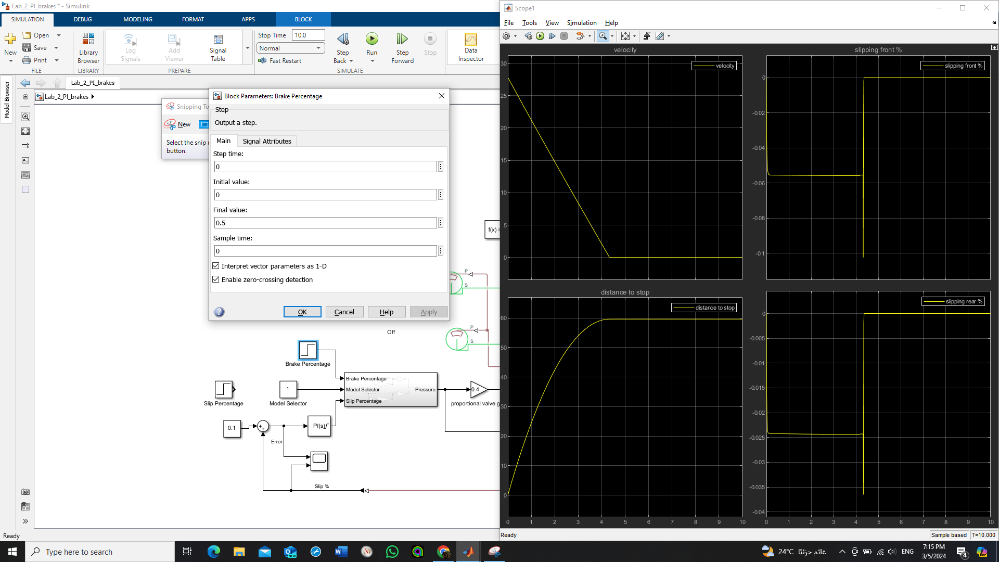

Figure 4 Result Lowest Distance no Slip

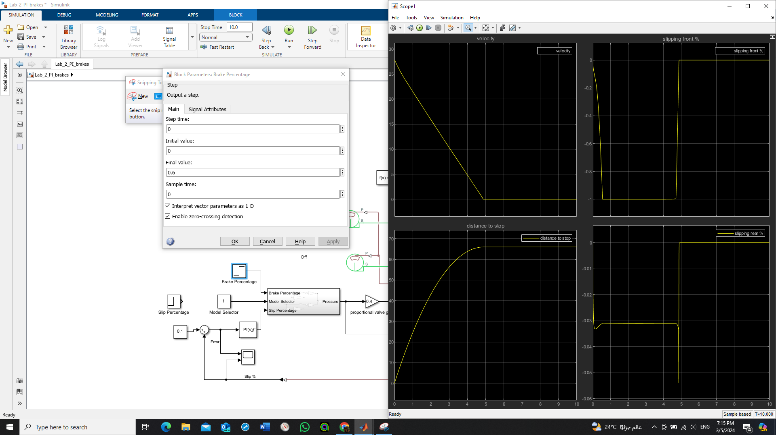

Figure 5 Lowest Human Force no Slip

Figure 6 Result

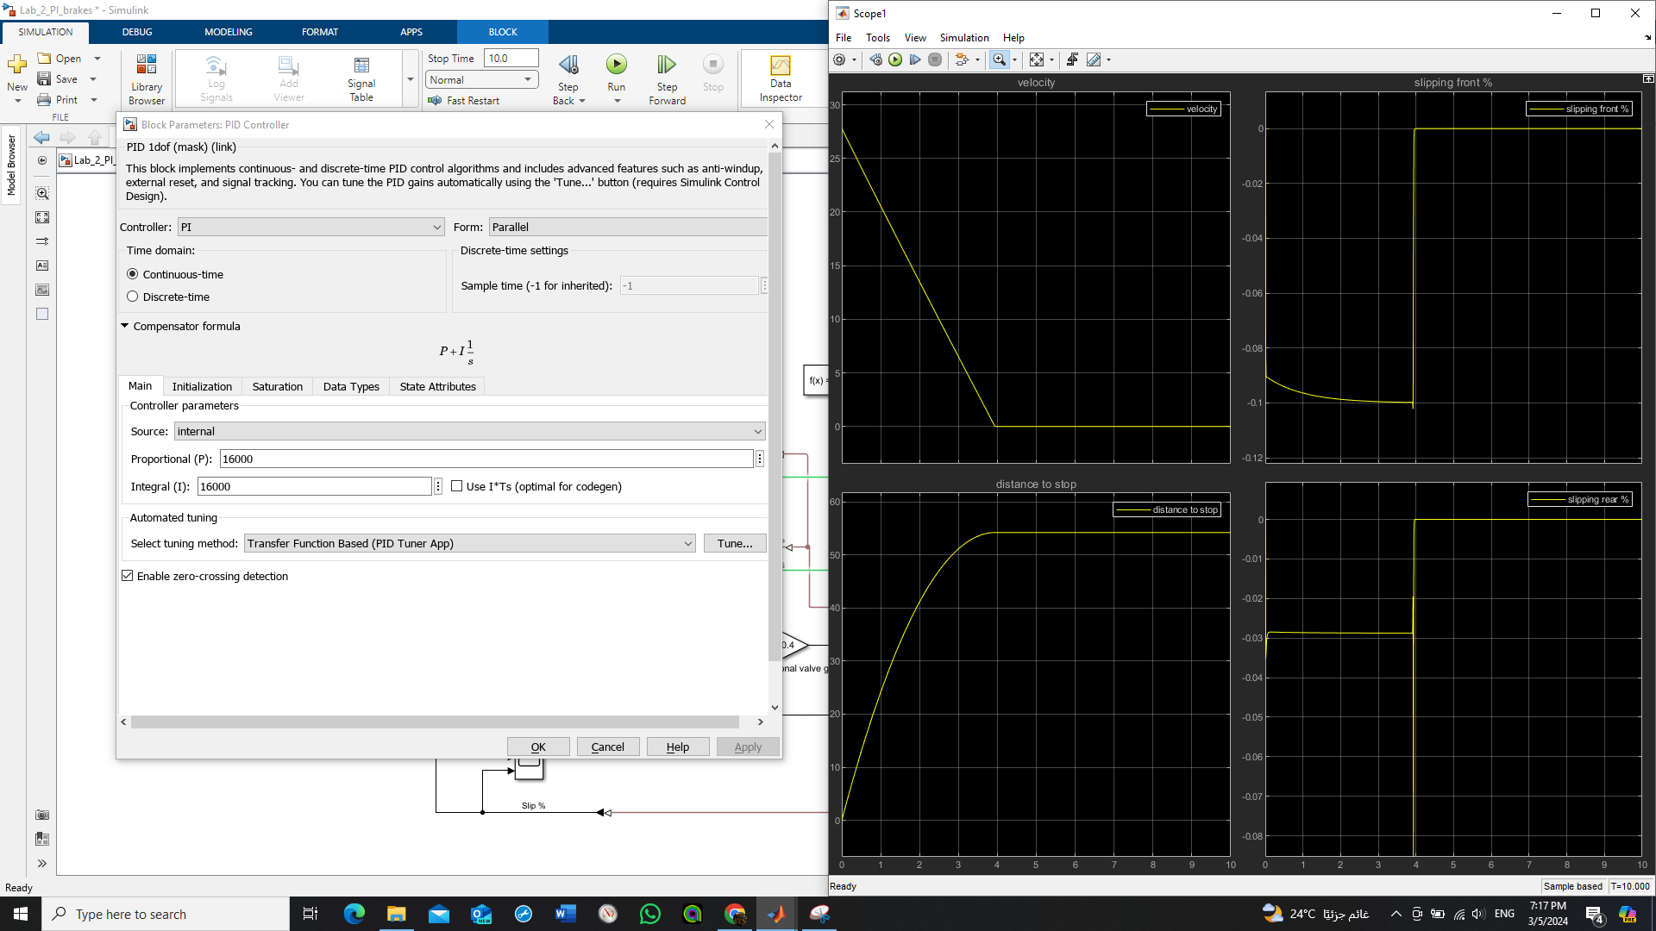

Figure 7 PI Controller



Figure 8 Result of PI Controller

Figure 9 MATLAB Live Script

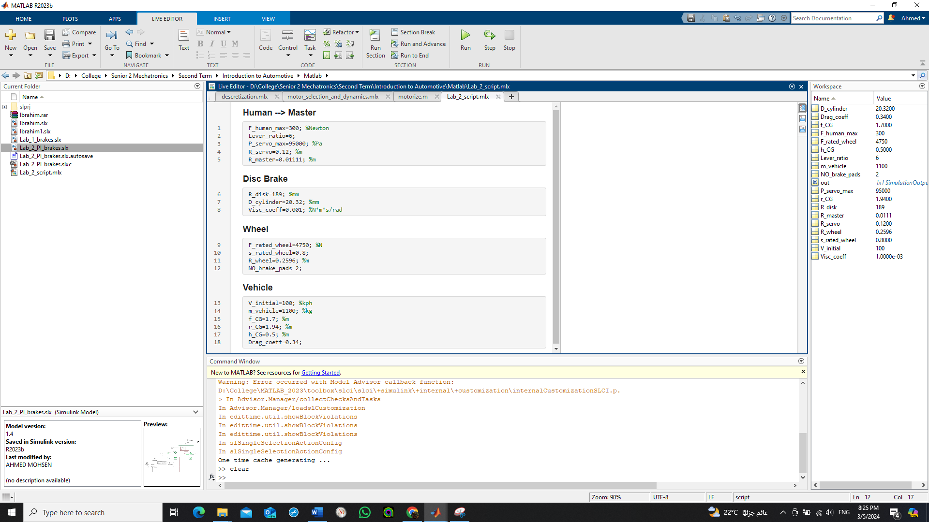

# Comments:

* The resulting stop distance with PI controller is lowest as the controller controls and tries to hold the slipping percent of front wheel at 0.1.
* If slipping occurs even if on one wheel the stopping distance increases.